Cloud Security Framework:
1. Definition: Cloud security frameworks are guidelines, best practices, and controls used by organizations to secure their data, applications, and infrastructure in cloud computing environments.
2. Purpose: They provide a structured approach to identifying and mitigating potential risks associated with cloud security.
3. Focus: Emphasizes maintaining security rather than achieving compliance or governance.

Cloud Compliance vs Cloud Governance Frameworks:
1. Cloud Security Frameworks: Address unique security challenges, shared responsibility models, and risk mitigation in the cloud.
2. Cloud Compliance Frameworks: Ensure compliance with legal and regulatory requirements for cloud services, focusing on specific standards like HIPAA, PCI-DSS, or GDPR.
3. Governance Frameworks: Broadly manage and oversee IT systems, including cloud environments, defining policies, procedures, and guidelines for decision-making, risk management, and compliance.

Common Cloud Security Frameworks:
1. MITRE ATT&CK: Standardizes stages of cyberattacks, focusing on tactics and techniques employed by hackers in the cloud.
2. Center for Internet Security (CIS): Offers standardized controls and benchmarks, evolving to include technologies for top cloud providers.
3. Cloud Security Alliance’s Security Trust Assurance and Risk (CSA STAR): Provides cloud security best practices and validates the security posture of cloud service providers.
4. ISO/IEC 27017:2015: Cloud-specific framework offering guidance on information security aspects specific to the cloud.

Regulatory Compliance and Standards Frameworks:
1. GDPR, FedRAMP, ISO 27001, PCI DSS, HIPAA, SOX, CCPA, FISMA, NERC CIP, NIST CSF, SOC 2, CMMC 2.0: Highlight various standards and regulations with specific security and privacy considerations related to cloud computing.

Best Practices:
1. Risk Assessment Strategy: Identify threats and vulnerabilities, prioritize response efforts, and establish appropriate security controls.
2. Policies and Procedures: Enforce policies to mitigate risks and maintain compliance with regulatory requirements.
3. Monitoring: Implement monitoring for early threat detection and rapid response to minimize impact.

CrowdStrike's Contribution:
1. CrowdStrike Falcon® Cloud Security: A cloud-native application protection platform providing unified visibility and security for multi-cloud and hybrid environments.
2. MITRE ATT&CK Detection Coverage: Offers 99% coverage for cloud workloads, containers, and serverless environments.
3. Comprehensive Cloud Security Risk Review: Provides insights into specific application security and regulatory needs.

Zero day Vulnerability – an unknown software flaw that a threat actor can target with malicious code.
Cloud Service Providers – CSP
Security and compliance framework – shared responsibility model

Three main cloud service models: SaaS, IaaS and PaaS
SaaS: In this model, a vendor hosts an application in the cloud, and anyone who subscribes can use it. Provider or the vendor is responsible for application security, and its maintenance and management.

PaaS: platform delivery model. Use to develop, run and manage applications. Vendor provides hardware and software. Used by application developers. Provider also responsible for security of platform and infrastructure.

IaaS: vendor provides virtualized servers, storage and network equipment (over internet). Customer is responsible for anything they own or install, i.e., os, apps, middleware, containers, workloads, data and code.
Middleware – software that acts as bridge connecting and enabling communication between different software applications or components.
Containers – packages that include everything needed to run a piece of software including the code, runtime, libraries and system tools.
In short,
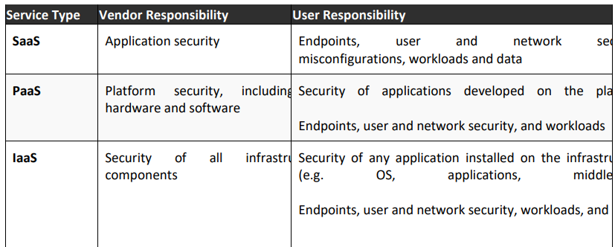

Compliance – conforming to rules, regulations, policies or standards.

Customers are responsible for:
- Identity access and management (IAM): Securing the interactions between digital entities within a network ensuring that access is granted and managed properly to maintain security and compliance.
- User security and credentials: Creating system where individuals can securely access resources by proving their identity through authentication mechanisms and using credentials to gain authorized access.
- End point security – protecting individual devices(endpoints) such as computers, laptops, smartphones.
- Network security: safeguarding integrity, confidentiality and availability of a computer network.
- Security of workloads and containers
- API (application programming interfaces)

Cloud providers are responsible for:
- Physical Layer: The actual hardware infrastructure in data centers.
- Virtualization Layer: Technology creating virtual versions of computing resources for efficiency.
- Network Control and Provider Services: Services managing and optimizing network performance in the cloud.
- Facilities that Run Cloud Resources: Physical locations or data centers housing and operating cloud infrastructure.

Advantages of shared responsibility model:
- Efficiency – security by csp, dedicate available resources
- Enhanced protection – monitoring and testing
- Expertise – knowledge and expertise in cloud security

Best practices:
- Check SLA – service level agreement
- Embrace DevSecOps
- IAM
- Trusted cybersecurity partner
- Prioritize data security

CrowdStrike’s Cloud Security Solutions
- Cloud security posture management
- Cloud workload protection
- AWS security
- GCP security
- Azure security
- Managed detection and response for cloud workloads

